PS C:\Users\lenovo\Desktop\anh ba hưng\mat ma ung dung\tai lieu va code\week03_code> python ChaoticSrreamcipher.py
=== Chaotic Map (Logistic) Stream Cipher Demo ===
This script uses a simple XOR-based scheme with a Logistic map keystream.
Disclaimer: Not secure for real-world cryptography.

Enter mode (encrypt/decrypt): encrypt
Enter path to input file: manchester.jpg
Enter path to output file: enmanchester_chaotic.jpg
Enter logistic map seed x0 (0 < x0 < 1): 0.5837495749
Enter logistic map parameter r (e.g., 3.99): 3.88

Encrypted file saved to 'enmanchester_chaotic.jpg'.
start enmanchester_chaotic.jpg
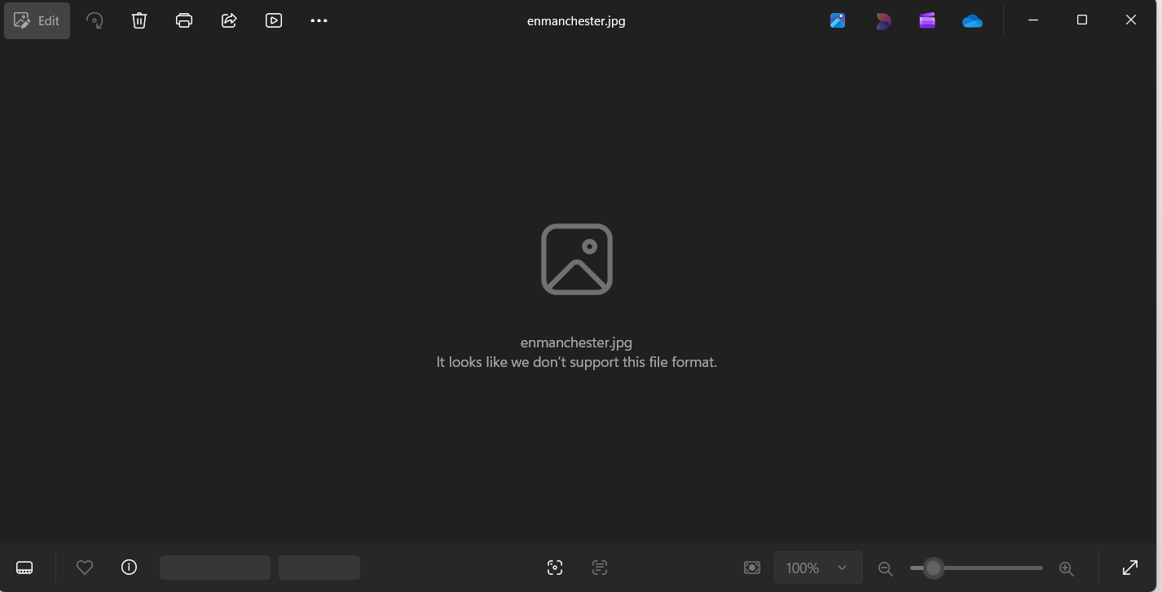
PS C:\Users\lenovo\Desktop\anh ba hưng\mat ma ung dung\tai lieu va code\week03_code> python ChaoticSrreamcipher.py
=== Chaotic Map (Logistic) Stream Cipher Demo ===
This script uses a simple XOR-based scheme with a Logistic map keystream.
Disclaimer: Not secure for real-world cryptography.

Enter mode (encrypt/decrypt): decrypt
Enter path to input file: enmanchester_chaotic.jpg
Enter path to output file: demanchester_chaotic.jpg
Enter logistic map seed x0 (0 < x0 < 1): 0.5837495749
Enter logistic map parameter r (e.g., 3.99): 3.88

Done. Decrypted file saved to 'demanchester_chaotic.jpg'.
start demanchester_chaotic.jpg


